A000-PAC-POLY-Marquesas-Nukuhiva-Outrigger Canoe-Wood-Early 20th c

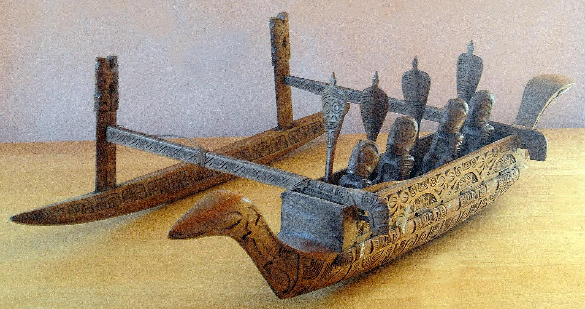

Fig. 1. PAC-POLY-Marquesas-Nukuhiva-Outrigger Canoe-Wood-Early 20th c, three quarter view.

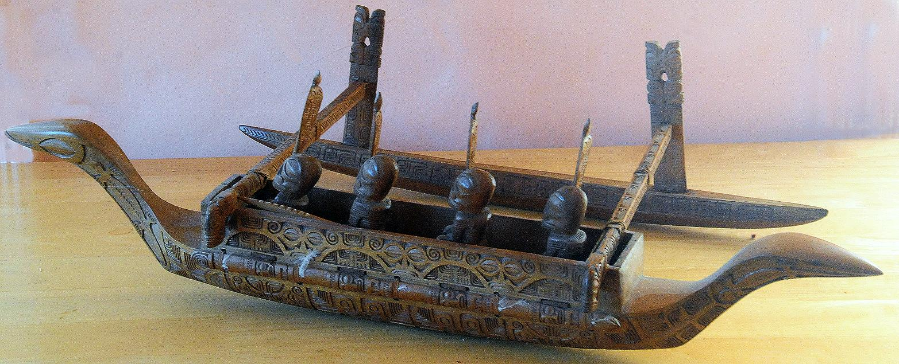

Fig. 2. PAC-POLY-Marquesas-Nukuhiva-Outrigger Canoe-Wood-Early 20th c, three quarter view.

, lateral view. Ex Mark Blackburn 1994.

Case No.: Oceania

**Accession No.**

**Formal Label:** PAC-POLY-Marquesas-Nukuhiva-Outrigger Canoe-Wood-Early 20th c, three quarter view.

**Display Description:**

This model of a Marquesan single-outrigger canoe has finely executed incised patterns on almost every part. It can be compared with the two old models in the Musée d'ethnographie, Neuchâtel, France, that also have similarly detailed incised engravings (see Hornell 1936: 35). The swan-neck prow-piece with a carved head was evidently the prerogative of powerful chiefs of Nukuhiva and Fatuhiva when Christian and Karl von den Stenen (1925-1928) saw canoes with this unusual prow form that were the vessels of paramount chiefs. No examples were found by commanded by Christian and Karl von den Stenen of commoners’ outriggers with carved swan-neck prow-pieces. The fore and aft prow pieces are both swan necks and almost identical except that the fore prow-piece has a carved head.

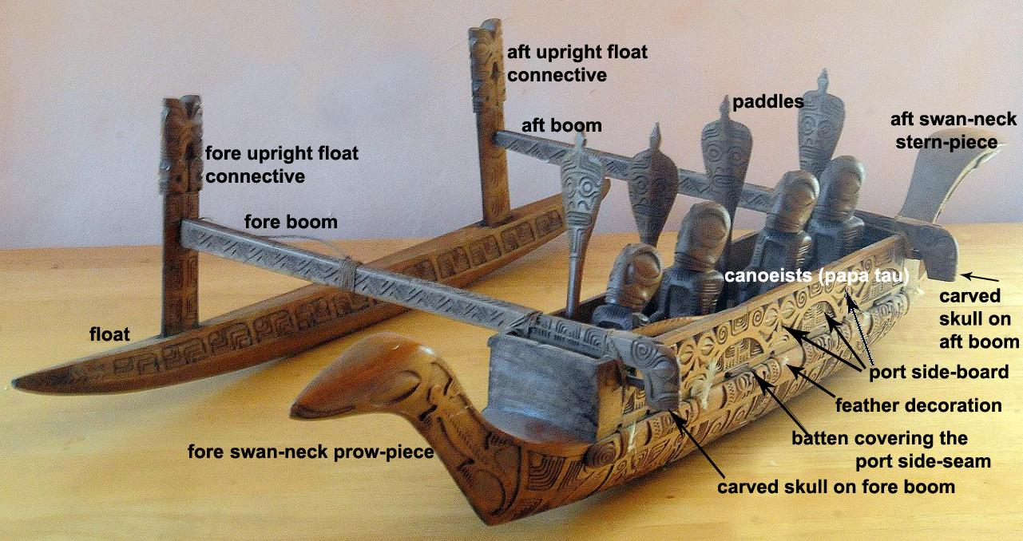

Fig. 3. Major parts of the outrigger model.

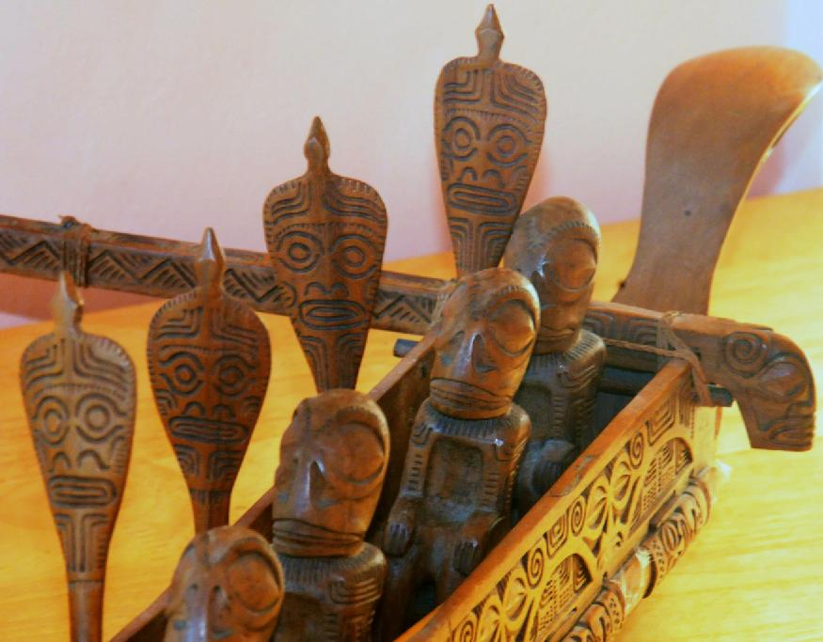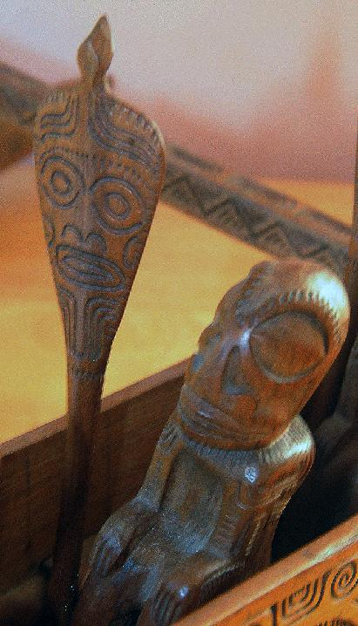

Fig. 4. Three quarters detail view showing canoeists carved with Marquesan stylistic features on *papa tau* seat slats that rest on an inner strip (*teka oto*) between the inboard seam of the sideboard and the hull. Also shown are carvings on the blade of the paddles, aft boom carvings, the aft swan-neck stern piece, the port side board and the port batten with feathers.

Each of the four canoeists is depicted in strict Marquesan style with facial features emphasizing oval eyes and arched brows, a small, flattened nose and a horizontal mouth, partially open. The four canoe paddles are also incised with apotropaic faces of powerful deities. Details of the canoe model were also true to the full-scale canoe. For instance, seats for canoeists (*papa tau*) rested on an inner strip (*teka oto*) that rests on an inner strip (*teka oto*) between the inboard seam of the sideboard and the hull. The “blade of the paddles belonging to war canoes of great chiefs were usually covered with carving” while blades of commoners were plain (Hornell 1936: 48). Therefore, we may surmise that this was meant to be a scaled-down replica of the war canoe of a great chief.

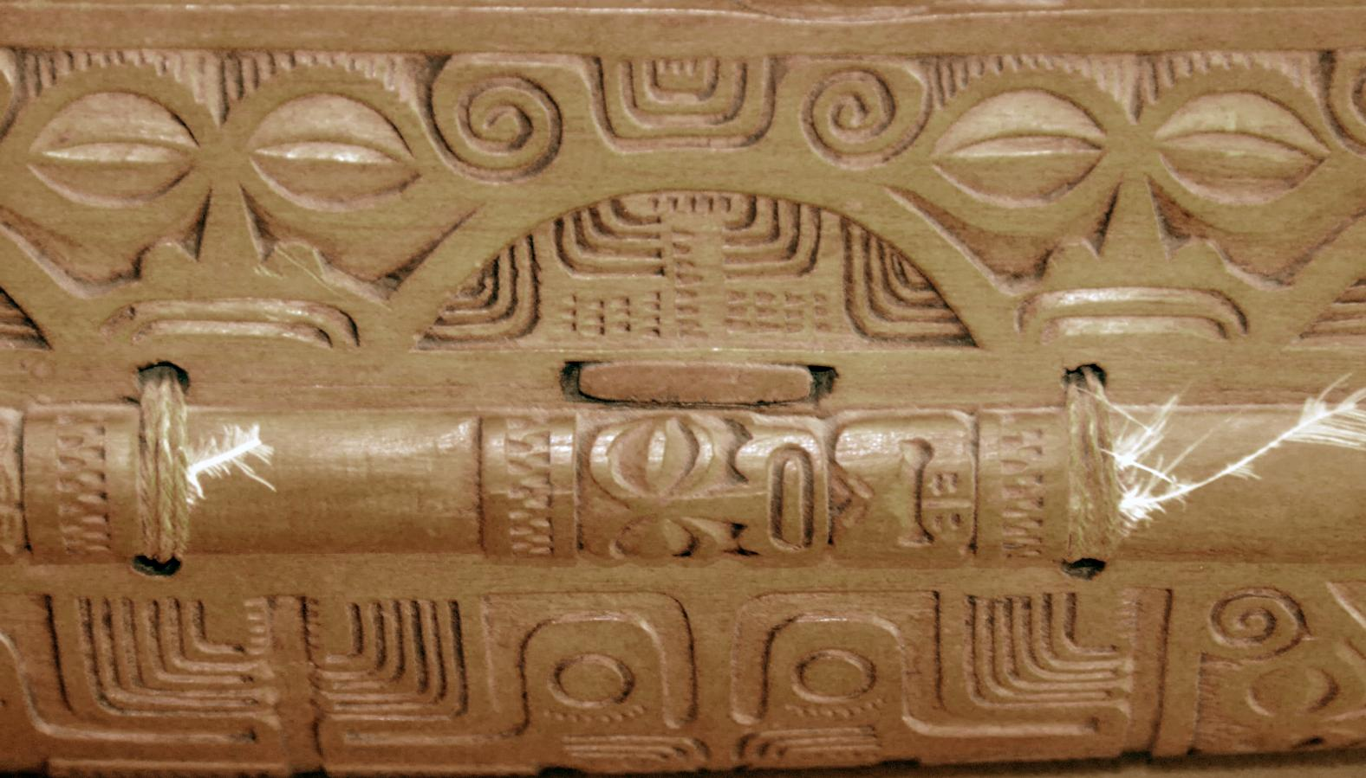

Fig. 5. Detail of the port sideboard.

The sideboard was intricately decorated with incised faces that suggest ancestral power riding with the outrigger (Hornell 1936: 41) and with “feather decoration of the battens covering the side seam” (Hornell 1936: 41) suggesting its speed was like that of a swift seabird.

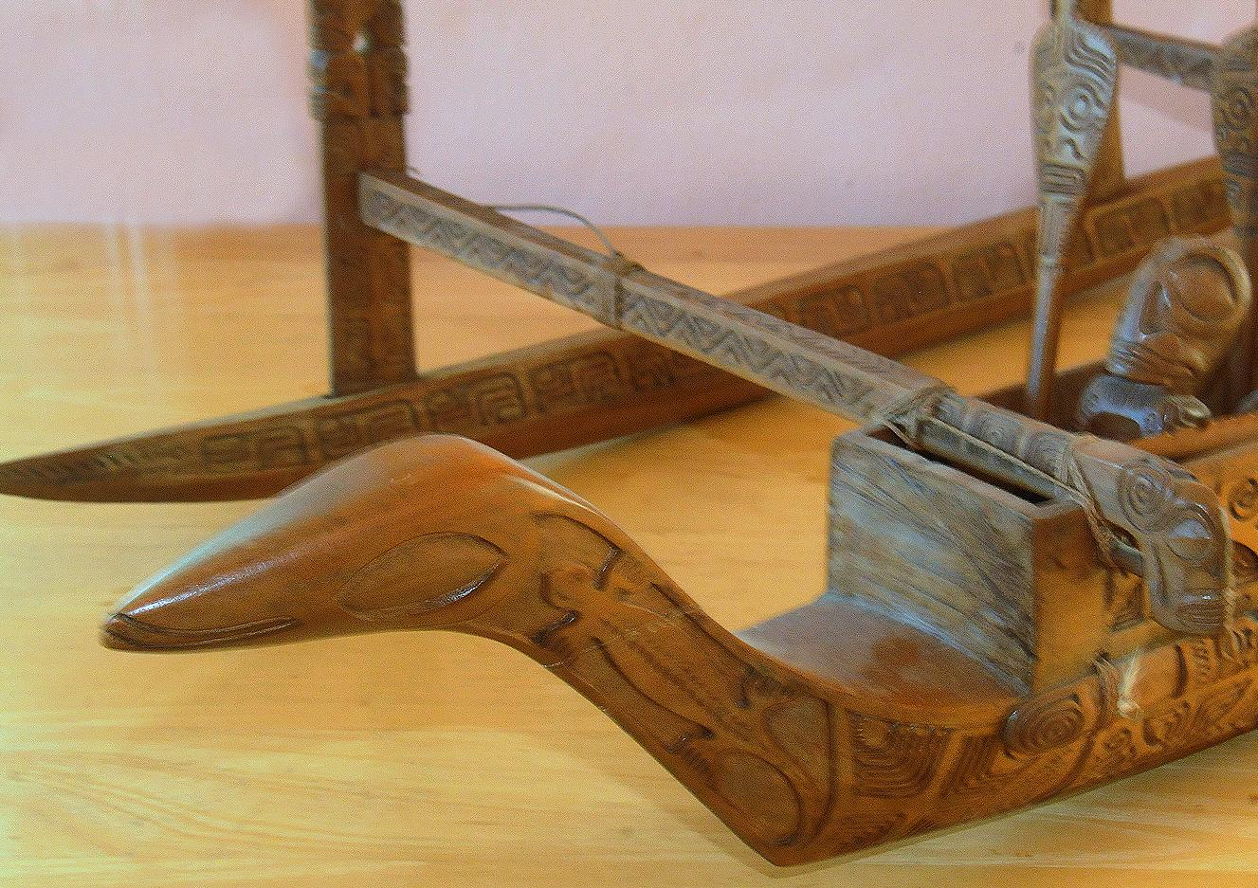

Fig. 6. View of the carved face on the swan-neck prow piece (only the face distinguishes it from the stern piece).

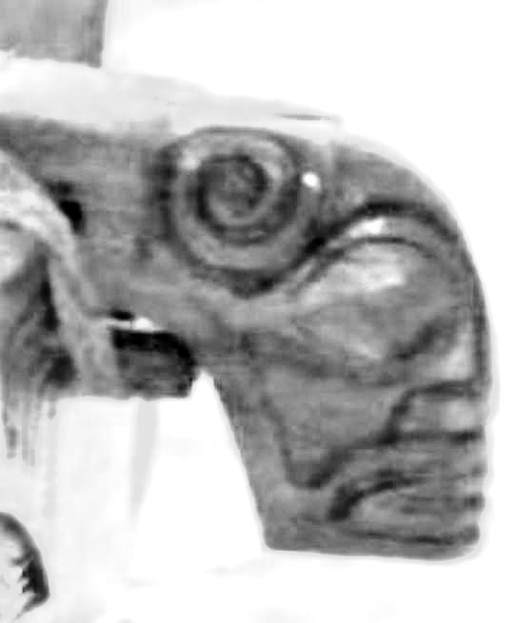 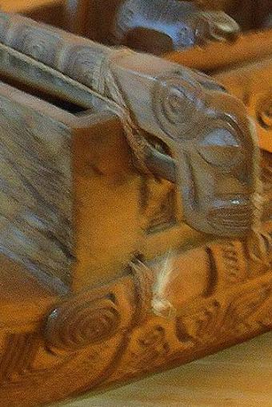

Fig. 7. Two views of carved skulls on the two boom ends (*kiato, hoa*), aft and fore, with representations of affixed eyes in each orbit (minus the mother of pearl on which a black pupil is painted on the full-size outrigger) and the representation in carving of a false nose of wood fitted into the nasal cavity and the tusk of a boar curving upwards in spirals above the head.

**LC Classification:**

**Date or Time Horizon:**

**Geographical Area:**

**Map:**

**GPS coordinates:**

**Cultural Affiliation:**

**Media:**

**Dimensions:**

**Weight:**

**Condition:**

**Provenance:** Ex Mark Blackburn 1994.

**Discussion:**

Skulls of enemies slain in battle (the perceived source of the chief’s power) were affixed to a war canoe’s fore-end piece (Fanning 1833: 129). A 1843 description of the skulls fits these carvings: “These skulls, bleached by time, are curiously ornamented; a piece of mother of pearl on which a black pupil is painted in inserted in each orbit; a false nose of wood is fitted into the nasal cavity and below the zygomatic arch; on each side of the jaws a long tusk of a boar curves upwards” (Vincendon-Dumoulin and Desgraz 1843: 282).

“A curious peculiarity of the Marquesan outrigger canoes … is that the outrigger is commonly on the starboard side, the converse of the usual practice in other Polynesian islands. Even where the two ends are identical [as in the current model], they are paddled generally with the outrigger on the right of the paddlers” (Hornell 1936: 44). The same custom of having the outrigger on the starboard side prevails in Napuka and the eastern Tuamotos both of which may have been colonized by Marquesans. The two booms of the outrigger (*kiato, hoa*) passed across the top of the canoe, being lashed to the top of each gunwale, or sideboard, by means of sennit that passed around the support and through holes in the board. These lashings were ornamental and were called *teka*. The float (*ama*) of this outrigger was also intricately incised and attached to the booms by intricately incised upright planks that were inserted into slots in the float.

The importance of the outrigger for the inhabitants of Nukuhiva cannot be underestimated. After the initial settlement of the Marquesas by voyagers from the west, the people of Nukuhiva continued to voyage, among their own islands, and between the islands of Nukuhiva and other groups. The following motives for leaving one's home island were many: "expulsion in war, famine, . . .a spirit of adventure and restlessness, and revelations of seers which led the people to set out on definitely organized expeditions for exploration" (Handy 1923: 19). Oral traditions of voyaging also suggest economic motives: to obtain exotic plants, animals and materials, such as red tail feathers of the tropic bird (Handy 1923: 20) and high-quality basalt for adzes on the uninhabited island of Eiao, which they traded with the people of Hiva Oa. In addition, when under stress Marquesans made war, obtained human sacrifices from other tribes, and revenged an enemy’s attack. Trading among the islands focused on the special product or two of each island that people on other islands desired: "Nukuhiva...produced the best *eka*, the turmeric root used in making saffron-scented cosmetics with which they covered their bodies. The carvers of Fatuhiva produced the best koa bowls for use in feasts and ceremonies (Dening 1980: 48), Ua Huka produced the best poi pounders and Ua Pou was noted for its porpoise-tooth crowns (Handy 1923: 23).

**References:**

Dening, Greg. 1980. *Islands and Beaches: Discourse on a silent Land: Marquesas 1775-1880*. Chicago: Dorsey Press.

Fanning, Edmund. 1833. *Voyages round the world: with selected sketches of voyages to the South seas, north and south Pacific oceans, China*. New York : Collins & Hannay.

Hornell, James. 1936. *Canoes of Oceania 1. The canoes of Polynesia, Fiji, and Micronesia.* Bishop Museum special publication, 27. Honolulu, Hawaii: Bernice P. Bishop Museum.

Handy, E.S. 1923. *The Native Culture in the Marquesas*. Honolulu: Bishop Museum.

Stenen, Karl von den. *Die Marquesaner und ihre Kunst : Studien uber die Entwicklung primitiver Sudseeornamentik nach eigenen Reiseergebnissen und dem Material der Museen.***.** 1925-1928. 3 vols. Berlin: Dietrich Reimer.

# Vincendon-Dumoulin, C. A. and C. Desgraz. 1843. *lles Marquises ou Nouka-Hiva; histoire, geographie,moeurs et considerations generales d'apres les realtions des navigateurs et les documents recueillis sur les lieux.* Paris : Arthus Bertrand.